Chapter 5, Solution 19.

We convert the current source and back to a voltage source.

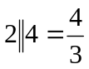
(1.5/3)V

+
−
4 kΩ
−
+
10 kΩ
(4/3) kΩ
v_{o}
2 kΩ
0V

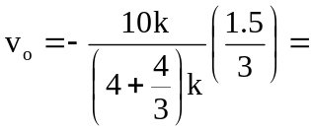–937.5 mV.
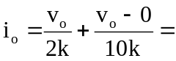 –562.5 µA.

